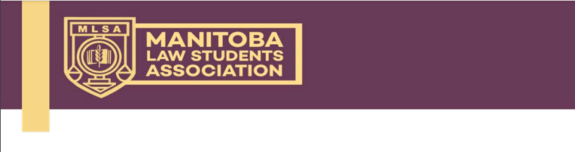
2023 – 2024
MLSA Member Cheque Requisition Form

Name (Cheque Payable To)
Committee/Group & Position
E-mail
Mailing Address

x This form must be accompanied by supporting documentation (an invoice and receipt, or bank statement or credit card statement showing amount paid and proof of payment).
x Multiple claims may be submitted on this form; reimbursement will be provided on one cheque. You may attach multiple forms if more space is needed and one reimbursement cheque is requested.
x Submit this form and direct any inquiries to Thomas Mooney, VP Finance
(rh.mlsa.vpfinance@gmail.com).

Date of Receipt | Issuer of Receipt | Amount Claimed | Description of Expenses

Total Amount Claimed: $

Any further information the MLSA may need to properly assess/process the reimbursement:

